Unit 5: Properties of Geometric Figures

Lesson 3: Polygons

answers

- Explain the difference between a regular and an irregular polygon. Provide a picture of each.
Regular polygon is a polygon which has equal sides and equal angles while irregular polygon does not have equal sides and angles.

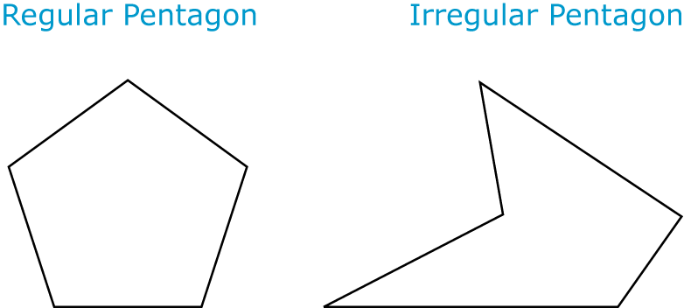
- A metal worker is producing information signs for a city park. Each sign will be in the shape of a regular hexagon with a side length of 75 cm. What is the surface area of the regular hexagon?

$S.A=\left(\frac{1}{2}×75×75\sin{60}\right)$6
$=2435.6964×6$
$$=14614.1784{cm}^{2}$$

- What is the sum of the interior angles of a 21-gon?

If the 21 sided polygon is regular each exterior angle = $\frac{360}{21}=17.14$
Interior angle $=180-17.14=162.86$
Sum of the 21 interior angles $21×162.86={3420.06}^{0}$

- Which of the following is a regular polygon?
Only d is a regular polygon
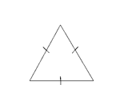
5. A blueprint for a pentagon-shaped table is drawn to a scale of 1:2. On the drawing, the sides are 0.5 m long and the angles are 108°. What are the side lengths and the angle measures of the table?
$$length=0.5×2=1m$$
$$angle={108}^{0}$$
6. A stop sign is a regular polygon. What is the sum of the measures of the interior angles of a stop sign?


$$sum=180\left(n-2\right)$$
$$180\left(8-2\right)$$
$${1080}^{0}$$

/ 7. James is designing a dining room light fixture. The base of the fixture is a circle with a diameter of 80.0 cm. James needs to place 8 lights on the circle, equal distance from each other. What is the distance between any 2 consecutive lights?

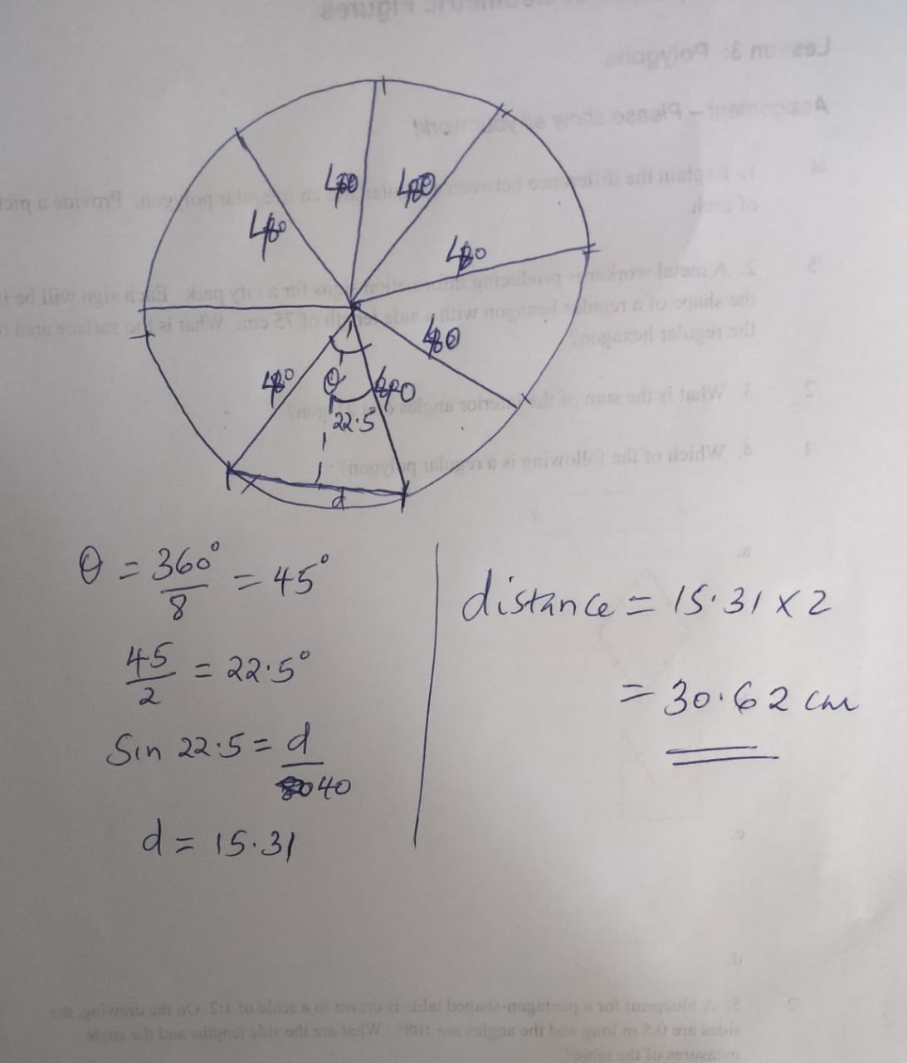

8. Mr. Ryan’s carpentry class is using wooden boards to construct a picnic table in the shape of a regular hexagon. Sara is cutting the boards for the top of the table.

- At what angle, x, should she make cuts on the board shown below?
x
x
board

$$angle=\frac{360}{60}={60}^{0}$$

- If the sides of the regular hexagon each measure 3 m, what is the area?

$area=(\frac{1}{2}×3×3\sin{60)}$6
$=3.897$×6
$$=23.382m^{2}$$

9. Archeologists unearthed parts of two adjacent walls of an ancient castle. From the diagram, how many sides did the regular polygon shaped castle have?

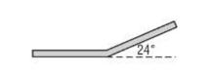
$$number of sides=\frac{360}{exterior angle}$$
$$number=\frac{360}{24}$$
$$=15 sides$$

/5 10. Find the missing angles.
a. 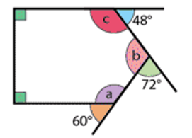
a = ${180}^{0}-{60}^{0}={120}^{0}$
b =${180}^{0}-{72}^{0}={108}^{0}$
c =${180}^{0}-{48}^{0}={132}^{0}$

b. 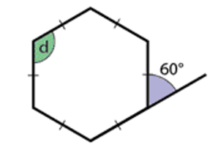
d = ${180}^{0}-{60}^{0}={120}^{0}$

c. 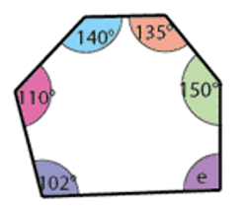
e =${83}^{0}$

11. Use the picture of the coin below to answer the next four questions.
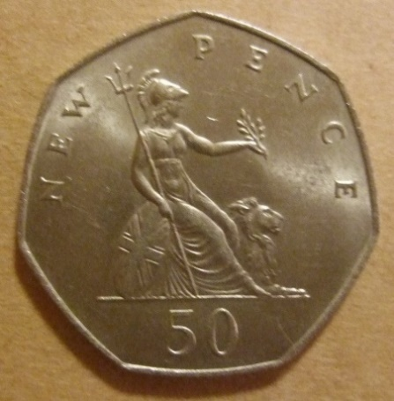
(Source: https://www.flickr.com/photos/woodysworld1778/6343231383)
- What type of polygon is the coin? heptagon
- What is the sum of the interior angles? 900⁰
- What is the size of each interior angle? 128.57⁰
- What is the size of the central angle? 51.43⁰

12. Use the following diagram for the next 3 questions.

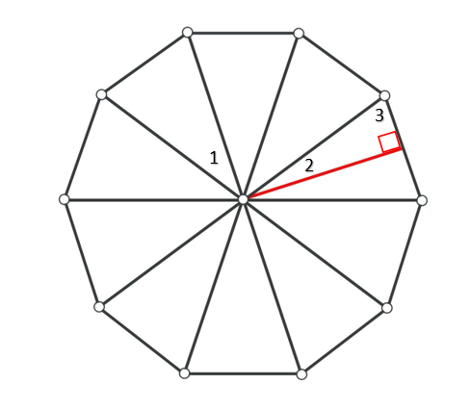
a.) What is the measurement of ∠1? = 36⁰
b.) What is the measurement of ∠2? = 18⁰
c.) What is the measurement of ∠3? = 72⁰

/5 13. Use the following diagram for the next 4 questions.

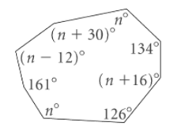
a.) What is the value of n? =125⁰
b.) What is the measurement of ∠(n + 16)°? =141⁰
c.) What is the measurement of ∠(n – 12)°?=113⁰
d.) What is the measurement of ∠(n + 30)°?=155⁰

Assignment Grade: /48

